Terms of Use for Images in the Economic Valuation and Sea Level Rise CGI Modules

**Images from the TEV CGI Module**

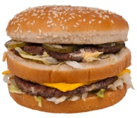

<https://commons.wikimedia.org/wiki/File:Big_Mac_hamburger.jpg>

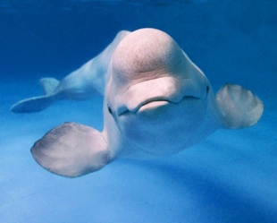

<https://commons.wikimedia.org/wiki/File:Beluga_premier.gov.ru-3.jpeg>

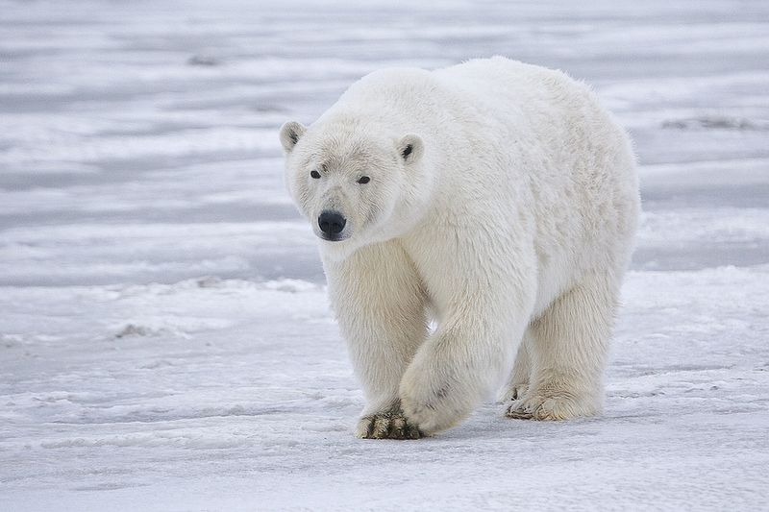

<https://commons.wikimedia.org/wiki/File:Polar_Bear_-_Alaska.jpg>



**Photo:**Jewelry made of reindeer antlers with reindeer etching |[Original photo by Linnea Nordström](https://www.flickr.com/photos/arctic_council/6830058203)

<https://www.flickr.com/photos/arctic_council/6830058203>

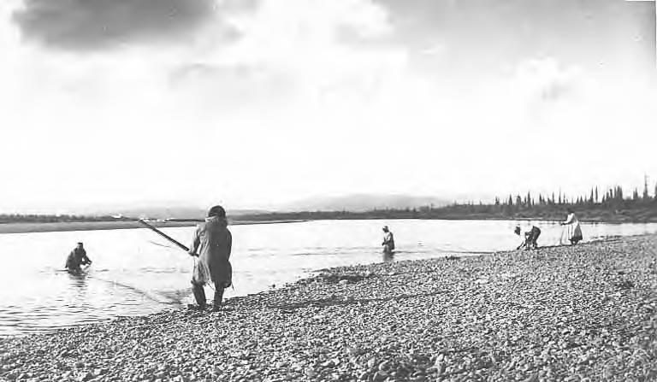

Public Domain from the University of Washington Special Collection

<https://commons.wikimedia.org/wiki/File:Five_Eskimos_fishing_from_the_beach_with_nets_(AL%2BCA_3314).jpg>

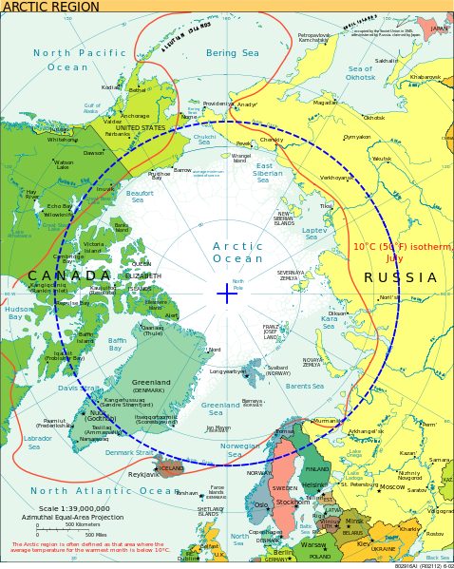

Public Domain from CIA world Factbook

<https://commons.wikimedia.org/wiki/File:Arctic_circle.svg>

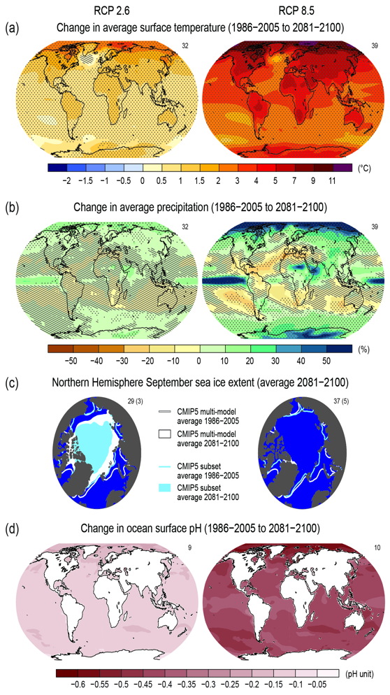

IPCC Copyright information: <https://www.ipcc.ch/copyright/>

Reproduction of limited number of figures or short excerpts of IPCC material is authorized free of charge and without formal written permission provided that the original source is properly acknowledged, with mention of the complete name of the report, the publisher and the numbering of the page(s) or the figure(s). Permission can only be granted to use the material exactly as it is in the report. Please be aware that figures cannot be altered in any way, including the full legend.

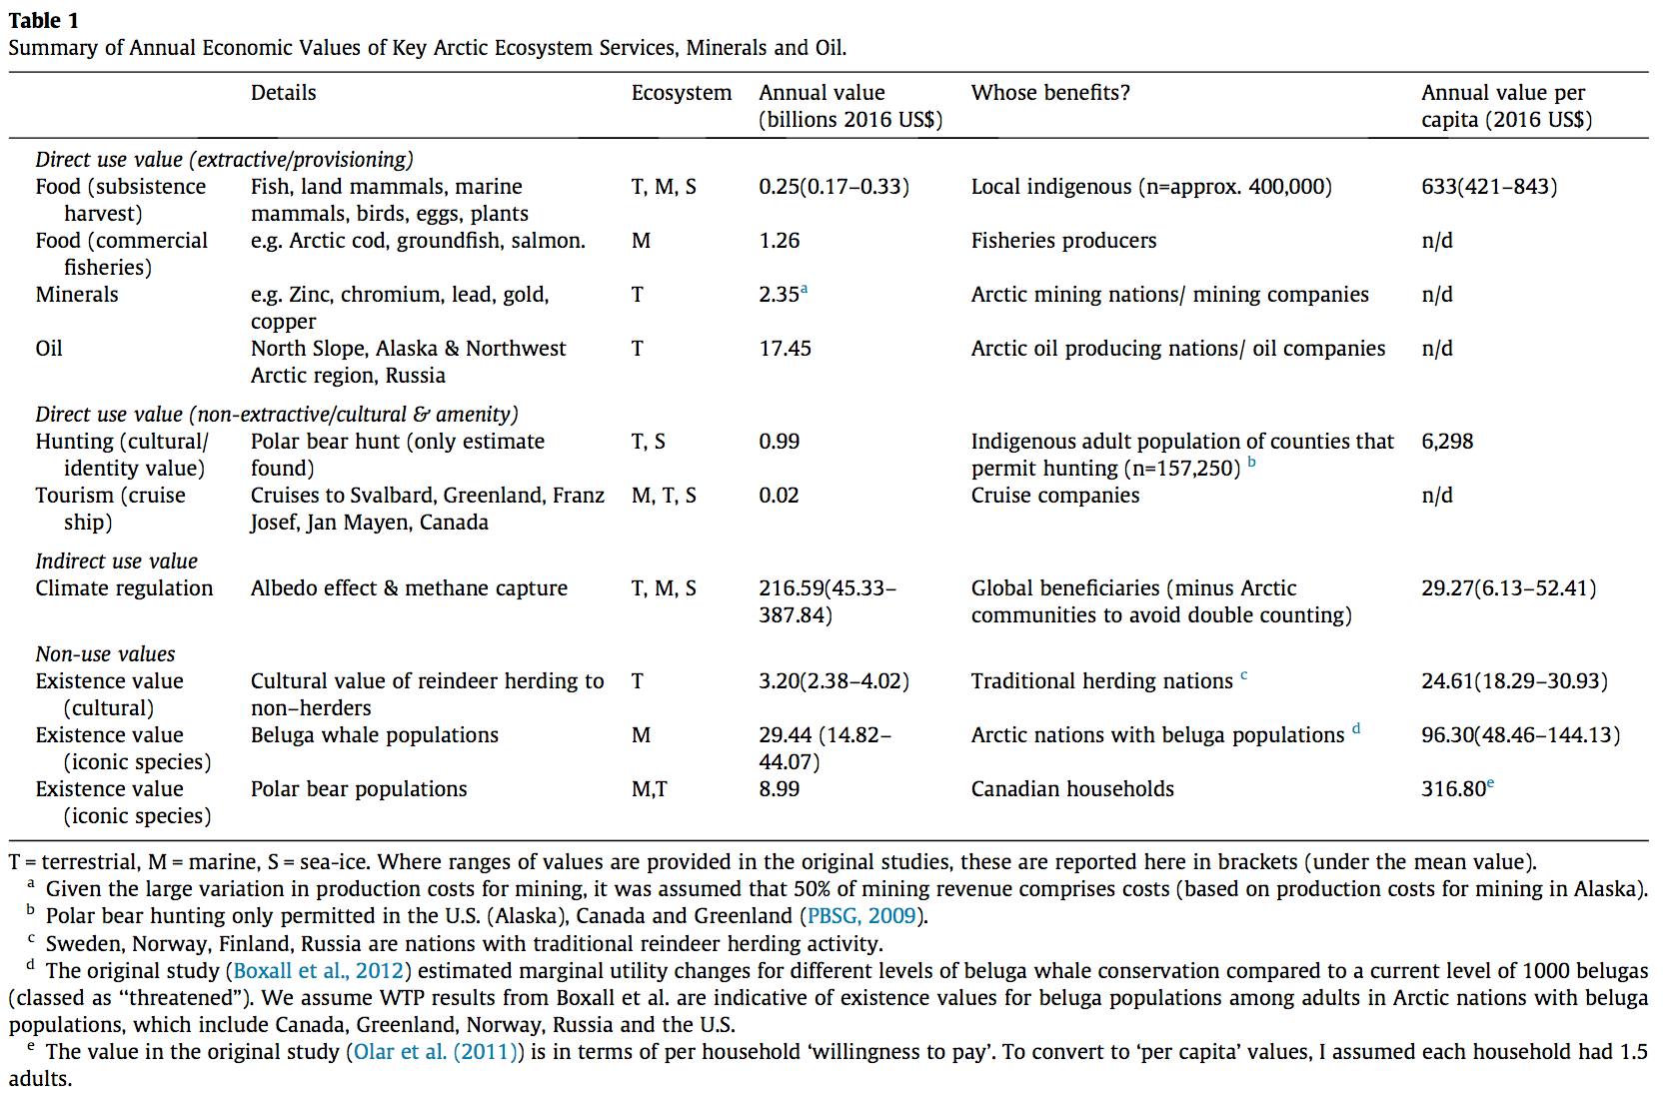

<https://s100.copyright.com/AppDispatchServlet?publisherName=ELS&contentID=S2212041616301309&orderBeanReset=true>

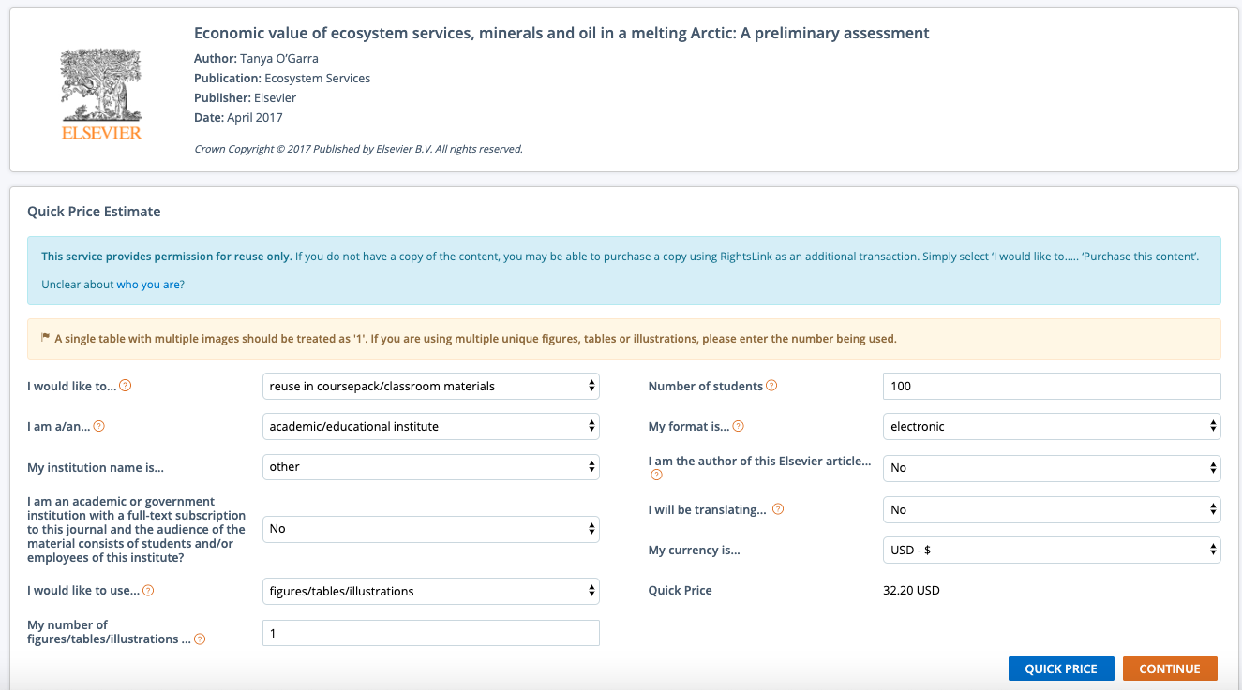

**SLR CGI Module Images**



Public Doman – SC National Guard

<https://www.flickr.com/photos/scguard/36564448210/>



NASA Media usage guidelines: <https://www.nasa.gov/multimedia/guidelines/index.html>

<https://www.flickr.com/photos/nasamarshall/32742778396/in/photolist-GecXjU-BtkoRg-GxTc1t-eLuGZE-RTnih1-RVA8jd-tN7Kz1-AfvmSC-v2MyX1-akaqq5-FRoQUo-9EiTDi-6ajkdb-kwPu43-28sHxHo-rRfrYv-pz19JZ-PEdBa4-2h1pno-5WokdL-bxN6z6-bkF2bV-Jy5u98-aaQD6Y-DDkPPQ-aJ8dTT-dxNPzJ-DDkSNA-aHtxoa-aQQWLB-pP4zKd-21v5H2E-QjEuSG-j8btFu-8o1a2v-4CfZiP-4CkgwQ-aFSvrP-QQp7TN-QHoRce-v5NS95-2pgFtb-bxNC8c-QQixUS-bSf8VF-5mSWdM-2fuB8Xm-9YPN8z-SkJ7Po-21zhVrR/>

Risk Finder Climate Central Maps

Climate Central <https://www.climatecentral.org/what-we-do/legal#content_licensing>

Reproducing Content from This Site

Non-commercial use: Unless otherwise noted on a particular page, materials may be copied without modification and subsequently distributed for non-commercial purposes (including use in study, research, teaching, planning, policy or communications purposes, or other non-commercial products or services), provided that you include clear and appropriate acknowledgement of Climate Central as source, and a link to climatecentral.org or the specific URL from which materials were drawn. We would be happy to answer your questions regarding republishing or licensing for Climate Central’s content, including stories, graphics, videos and photos. Please contact us at permissions@climatecentral.org for more information.

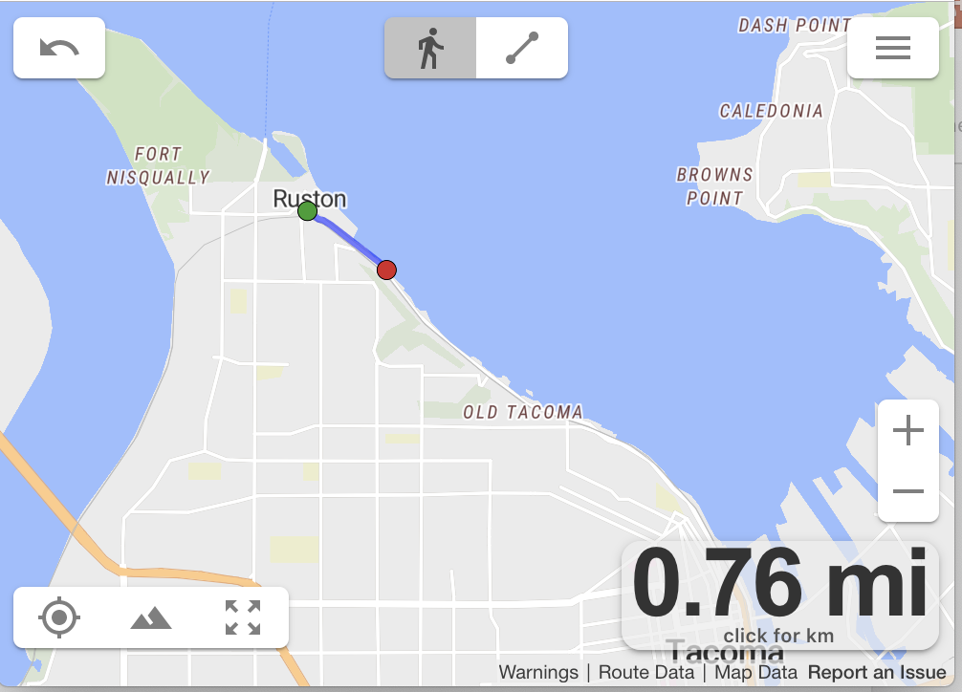

<https://onthegomap.com/terms/>

You may use the website to:

View maps and create routes

Publicly display routes you create with attribution as described below online, in video, and in print



ERSI terms of use: <http://downloads2.esri.com/ArcGISOnline/docs/tou_summary.pdf>

Include screen captures or a printed or plotted maps in the following ways • Personal use, internal business use, or include in a presentation or a report for a client • In brochures and marketing collateral, or on a company web site to promote your own products and services and display your store locations • In academic publications (research journals, textbooks, etc.)